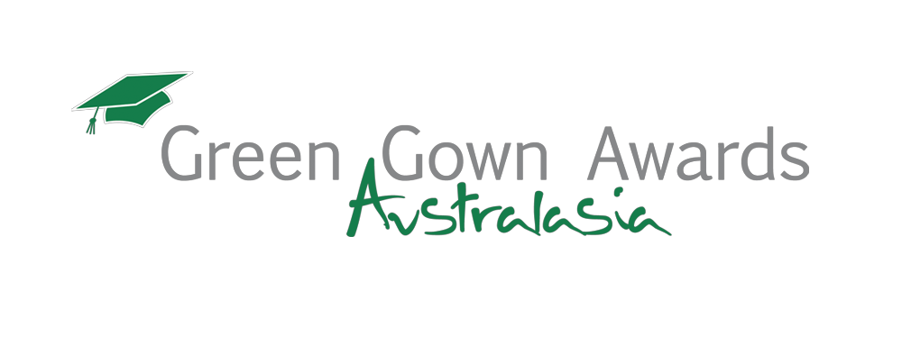

2016 Marketing Information

Information is required from all applicants for use by the Green Gown Awards Australasia team for marketing activities. Please submit this form [HERE] (in word format only), with your 2016 application form. If you are nominating, or have been nominated, for an Individual Award (The leadership Award or the ACTS Awards of Excellence) you do not need to submit this form.

CONTACT INFORMATION
Name
Job Title
Organisation
Title of project
(ensure this matches the title on your application form)
Category entered
PROJECT SUMMARY (this text will be used if you are a finalist, winner or highly commended)
Please summarise (in less than 100 words) your initiative. Include the benefits to your institution, and individuals, as well as any results and achievements which have materialised as a direct result of the project. (Please ensure this information is as succinct and ‘catchy’ as possible. This text will be used in marketing activities, so please ‘sell’ your initiative as much as possible. Please try not to copy the project summary from your application).
What would it mean to your institution to win a Green Gown Award?
Please ask your Vice Chancellor/Principal to provide the quote.
Please state what winning a Green Gown Award would mean to you and your institution? Important: please ensure the quote is referenced. Include the full name and title of your Vice Chancellor/Principal or staff member.
Please include the top three learnings from implementing your project. This can act as advice to others who may be starting out on their projects.

Tip: Please ensure you provide bullet points, which are as succinct as possible (no long sentences or paragraphs please. Try to keep each point to one line maximum).
1
2
3

You have now completed your 2016 marketing form. Please ensure you have filled in all sections.

ACCOMPANYING MATERIAL:

All accompanying material will be uploaded with the marketing form at the time of submission.
Please ensure you have:

- Up to three high-resolution electronic images* that are relevant and appropriate for this project. Please label the file name appropriately.
- A high resolution electronic logo* of your project and/or institution

* Image & logo requirements: minimum of 300 dpi jpeg, jpg or png format

FOR INFORMATION ONLY:

A finalist brochure will be produced in advance of the Awards ceremony. A winner’s summary will be available after the Awards. ALL finalists, highly commended and winners will be required to submit a case study video as part of the Awards’ commitment to drive dissemination to the wider sector. All videos are to be submitted by Wednesday 26 October 2016 and further details will be provided when the finalists are announced. By submitting your application, you are agreeing, should you be selected, to take part in the dissemination.

We ask all applicants to please supply a copy of all promotional materials (press release and articles etc) to the Green Gown Awards Australasia team for international dissemination via the ACTS resource bank and for possible use in future marketing activities.

If you have any questions relating to your application, please contact ggaa@acts.asn.au.

Disclaimer: By submitting this information you are giving permission to Australasian Campuses Towards Sustainability (ACTS) to use this information for marketing and PR purposes for all Green Gown Awards related activities. This information must be submitted with your application. This information has no bearing on your application and will not be seen by the judging panel.

